**GOVERNMENT DEGREE COLLEGE, GUMMALAKSHMIPURAM**

**Name of the Event: Awareness Session Health & Hygiene**

**Guest of Honor : Dr T. Sreevaram Principal**

**Date                      : 22-10-2024**

**Organized by           : Women Empowerment Cell**

**Lecturers Attended: 06**

**Students Attended: 80**

**The Awareness Session was organized by WEC on 22-10-2024, the topics for the programme were, discipline, mental health and hygiene, maintaining relationship with boys, proper use of toilets, the purpose of the session. Nearly 80 students, women staff participated and made the event successful.**

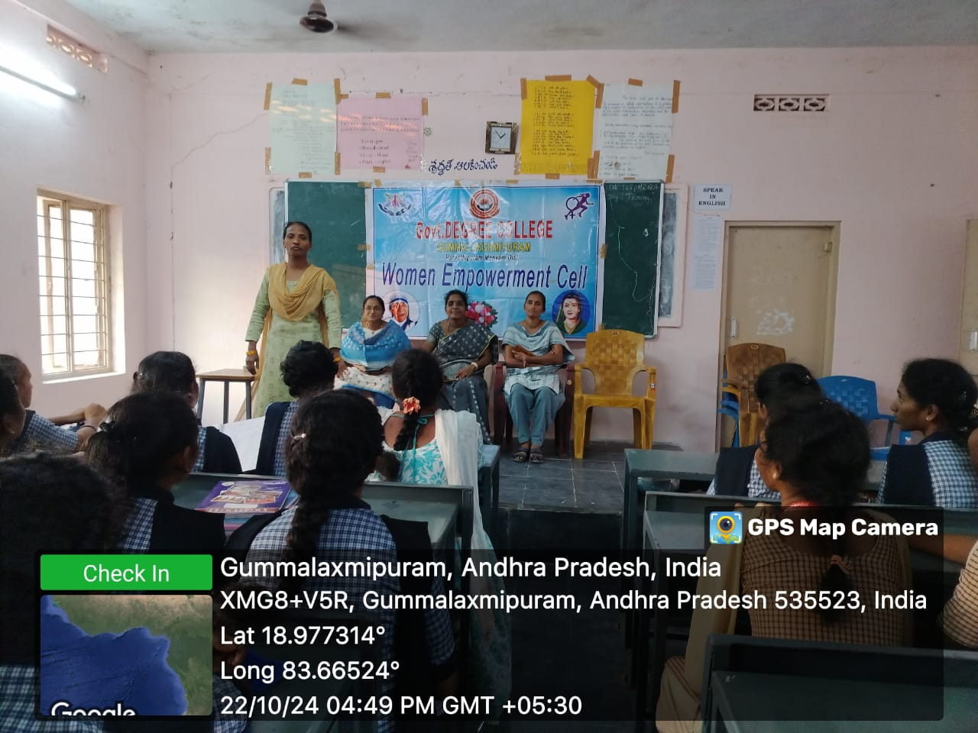

**WOMENS CO ORIDINATOR SPEECH: It is an honor to stand before you today as we discuss a topic that affects every woman—health and hygiene. Maintaining good health and hygiene is not just about personal well-being; it is also about dignity, confidence, and empowerment. Women play a vital role in families and society, but often, our own health takes a backseat. It is crucial to prioritize nutrition, mental well-being, menstrual hygiene, reproductive health, and general cleanliness in our daily lives.**

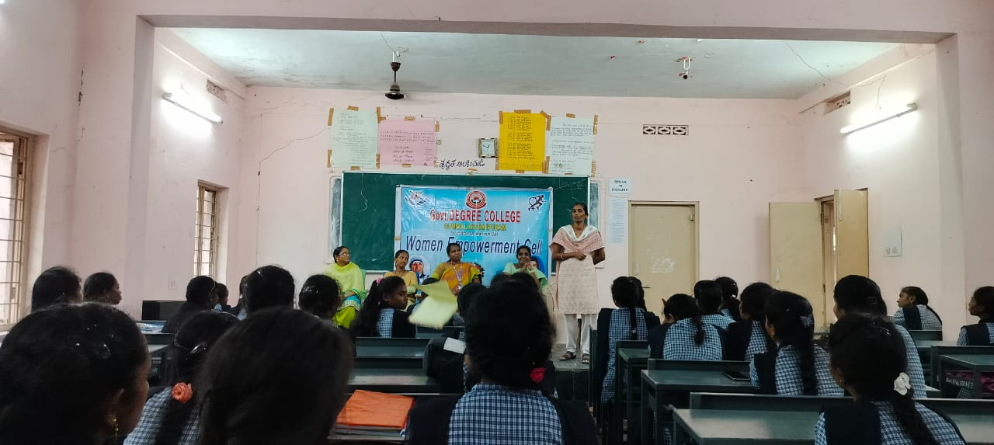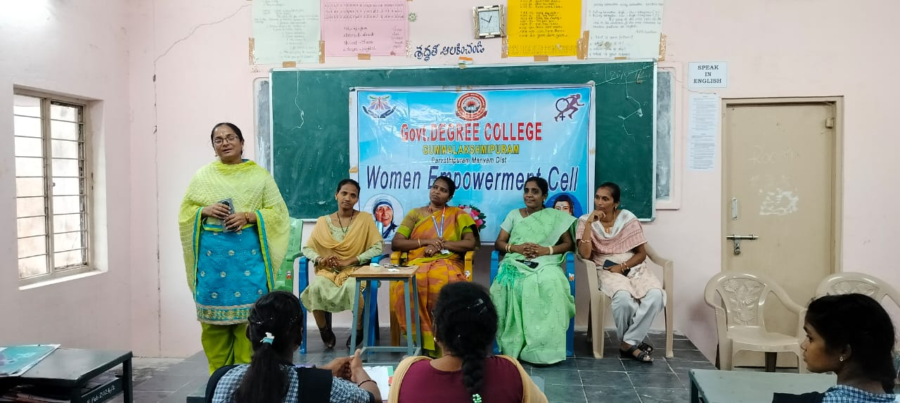**Conclusion:**

**Health and hygiene are the foundations of a strong and confident woman. When we take care of ourselves, we set an example for future generations. Let’s educate, empower, and support each other in maintaining a healthy lifestyle. Remember, a healthy woman is a strong woman, and a strong woman builds a stronger society!**